“New and Improving”
Siler City Country Club

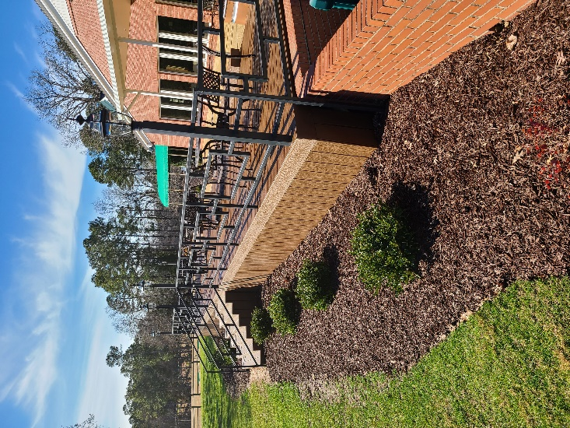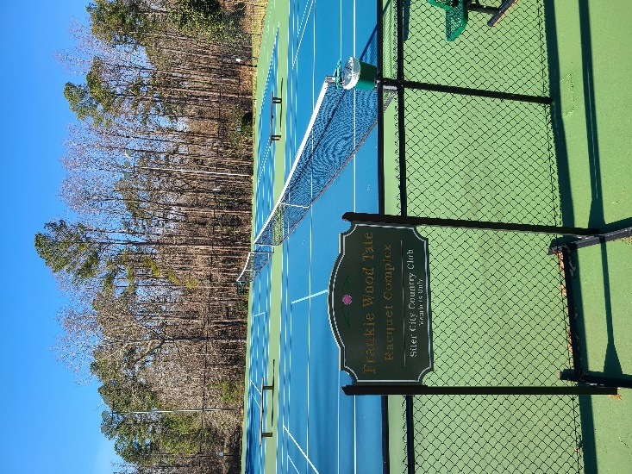

Reasons Why I Should Join Siler City County Club:
________________________________________________________________________________________________

- Newly Installed TifEagle Bermuda grass greens
- Newly Renovated Pickleball and Tennis Courts.
- Newly Renovated Golf Shop.
- Ellis Maples/Tom Jackson Championship Course Design.
- Variety of fun and competitive golf tournaments.
- Membership that fits your needs.
- Club Storage & Lockers available.
- PGA Professional teaching – clinics, private lessons and group lessons.
- Range Plans available.
- Member Discounts on Golf Shop merchandise.
- Preferred Tee Times for members 15 days in advance.
- Full-Service Golf Shop including: club repair and custom orders.
- Olympic size swimming pool & wading pool.
- Member Events for Men, Ladies, & Juniors.
- Lounge, Dining Room, and Patio feature pristine views of the golf course. We serve a variety of options from our lunch and dinner menus. Daily Specials are served Wednesday – Saturday from 11am-10pm and Sundays from 12pm- 4pm.
- New Patio Trex Decking & Landscaping.
- Clubhouse rental is available for those Special Occasions! Birthdays, Weddings, Banquet Events, and Christmas parties.
- All facilities are available for Special Events.
- Tennis/Pickleball - Members Only.
- Our professional friendly staff is here to make your experience at the Club paramount.
- Free Wi-Fi in the Clubhouse.
- Special Holiday Events for members and their guests.
- Putting Green & Short game practice area.

Siler City Country Club
TYPES OF MEMBERSHIPS

Category: Monthly Dues:

FULL MEMBER –
Full access to Club, Pool, Dining, Tennis, and Golf $215.00

JUNIOR MEMBER –
(18-34 years old)
Full access to Club, Pool, Dining, Tennis, and Golf $178.00

SOCIAL MEMBER –
Full access to Club, Pool, Dining, Tennis, and Limited Golf $145.00
Limited Golf: 7 Rounds Per Year

**Each membership has a required Food Minimum purchase per quarter in the amount of $60.00
**Each membership has a required Entertainment fee every quarter in the amount of $10.00

Amenities: Rates:

Men’s Locker Rental $100.00 / year

Handicap Fee $30.00 / year

Range Plan:
Family Plan $100.00 / year

Trail Fee (Personal Cart) $990.00 / year

Siler City Country Club
MEMBERSHIP APPLICATION

DATE: ___________________________________________ MEMBER NUMBER: _________________________________

PLEASE CHECK ONE MEMBERSHIP CATEGORY:

Full Mmebership ___ Social Membership ___ Junior Membership (age 21-34) ___

LAST NAME |  | FIRST NAME |  |  |  | DATE OF BIRTH
HOME ADDRESS |  |  |  | CITY |  | STATE | ZIP
HOME PHONE | CELL PHONE |  |  |  | EMAIL ADDRESS
BUSINESS ADDRESS |  |  |  | CITY |  | STATE | ZIP
BUSINESS PHONE |  |  | BUSINESS EMAIL ADDRESS

I prefer communications sent to: Personal Email ________ Business Email ________

DEPENDENT FAMILY MEMBERS TO INCLUDE:
NAME | RELATION | PHONE | EMAIL ADDRESS | DATE OF BIRTH

*Dependent Family Member shall mean the member’s spouse, a domestic partner, and any unmarried son or daughter, up to 18 years of age who is a dependent of and resides with said member, or an unmarried full-time student obtaining a higher education up to 24 years of age who is a dependent of said member.

COMMUNICATIONS AND STATEMENTS

Subject to approval by the Club and payment of fees and dues (dues pro-rated if applicable), I wish to have my membership become effective on:
____________________________ ______________
Date (within 30 days of application) Initial

If this application is not approved by the Club, all funds deposited herewith shall be immediately refunded. It is agreed that I may resign from the Club by giving thirty (30) days advance written notice to the Club and by paying all dues and other charges for which I may be liable, and I shall not thereafter be subject to any further dues or charges. It is further agreed this is not a stock.

AREAS OF INTEREST
Please check all that apply:

 | GOLF (MENS) |  | GOLF (LADIES) |  | GOLF (YOUTH)
 | TENNIS (MENS) |  | TENNIS (LADIES) |  | TENNIS (YOUTH)
 | PICKLEBALL (MENS) |  | PICKLEBALL (LADIES) |  | PICKLEBALL (YOUTH)
 | SWIMMING |  | WATER AEROBICS |  | BRIDGE
 | DINING |  | SOCIAL

RULES AND REGULATIONS

As a member, I agree to conform to and be bound by the rules and regulations of the Club and understand they may be amended from time to time. Any rules violations subject the membership to revocation without refund.

Applicant Signature: ________________________________________ Date: __________________________

*a membership bond in the amount of $1,800 is required to join. You have up to 18 months to pay for the bond. a $250 non-refundable application fee and a 12 month commitment will be required at time of submitting the application*

OFFICE USE ONLY

Accepted Denied

Approved Date: _________________________ Signed: ____________________________________

Siler City Country Club

12-MONTH COMMITMENT FORM

I hereby accept a one-year membership to join the SILER CITY COUNTRY CLUB. I fully understand that I must maintain my membership account in good standing, under the membership category I choose, for a period of no less than 12 consecutive months from the date my membership begins. The one-year membership commitment may be cancelled prior to the maturity date as follows:

If cancelled within the first year of the commitment, a penalty payment of $500 is required
along with the resignation of membership from the SILER CITY COUNTRY CLUB.

At the end of the 12-month agreement the membership will automatically renew on a month-to-month basis and resignation from the club can be given with a 30-day written notice where if the resignation notice reaches us by the 5th of the month, the resignation will be effective at the end of that month. No refunds will be given for partially used periods of dues or services.

Signature: ________________________________________________________________

Printed Name: ____________________________________________________________

Date Signed: _______________________ Maturity Date: _________________________
(staff use only)

Sign Up for Automatic Credit Card Drafting of Your Monthly Dues

Credit Card Authorization ____ MasterCard _____ Visa _____ Discover ______ Amex
Account Number: ( ) CSV code
Expiration Date:
Print Name on Card:
Signature:
_____ Bill the Total Due (Current Month's Dues) Only
_____ Bill this month's total PLUS all future charges, until notified in writing by me to discontinue
automatic credit card billing.

Return this form to the Golf Shop and we will get your account set up.

Siler City Country Club
New Member Sponsorship Certificate

This certificate is being presented

To: ___________________________
NEW MEMBER (Please Print)

From: _________________________
SPONSORING MEMBER (Please Print)

Staff Use Only
Staff Initials: _________ Date Received: _________

